

**SEMESTER PROJECT REPORT - WEBSIte**

**Course:** IICT – FALL 2023

**Instructor:** Ma’am Bushra Fatima

**BY:**

Abdullah Razzaq (23I-0057)

Hasan Naveed (23I-0797)

# LOGIN PAGE

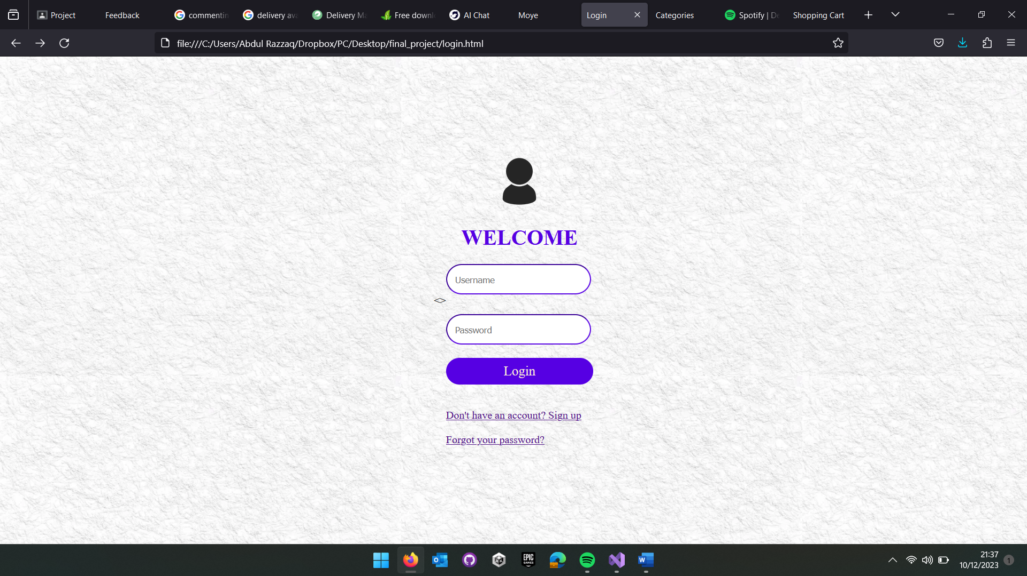

The Login page which prompts the user to enter their username and password. If they do not have an account already, a sign up button has also been provided underneath, as well as a link in case they have forgotten their password.

The user is redirected to the homepage, sign up page, or the forgotten password page depending on his/her choice.

SIGNUP PAGE 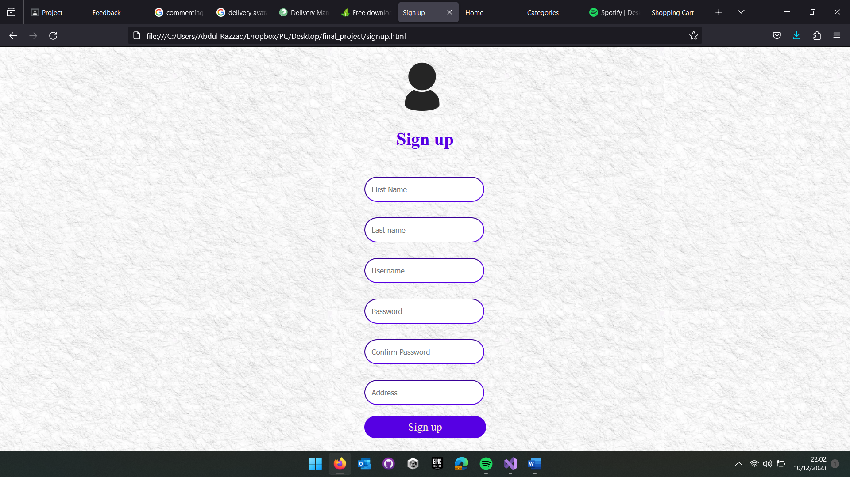

# HOMEPAGE

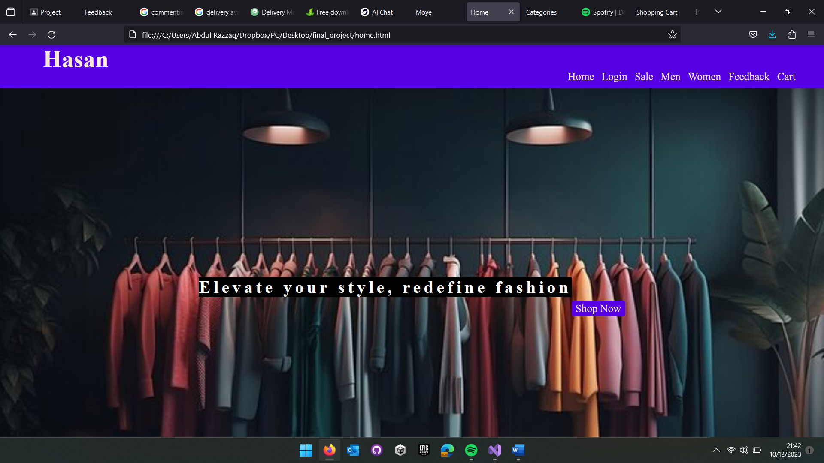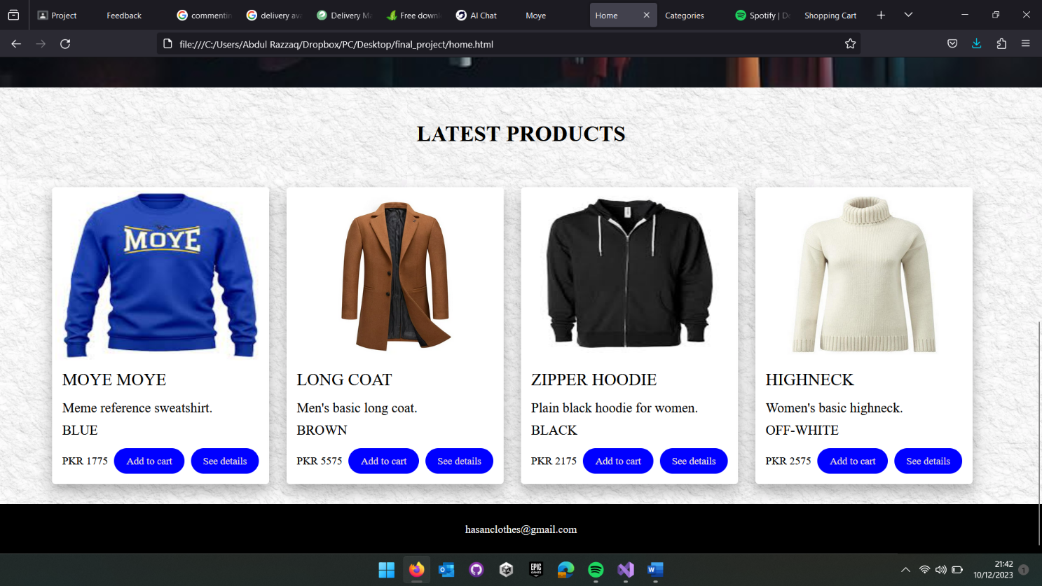

The homepage of the website, with a well-designed layout, the logo and navigation bar on top containing a button for each page and an eye-catching background to capture attention of the user. A “shop now” button will take user to the categories page. A list of products has also been provided on the homepage to give the user a glimpse of the type of products available. We have tried to keep the design minimalistic.

# CATEGORIES

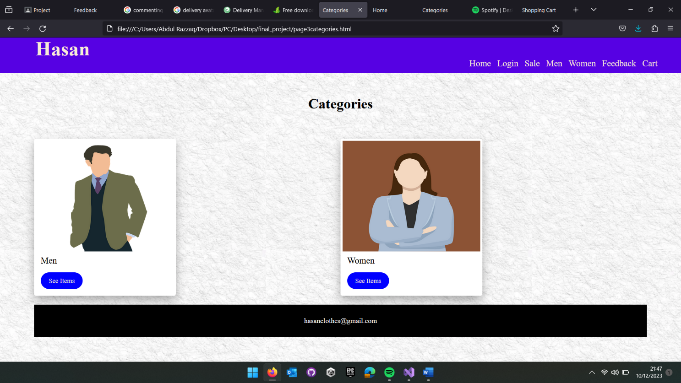

The categories page allows the user to choose between the available categories. By clicking on “see items” they are taken to the respective category page.

# MEN/WOMEN

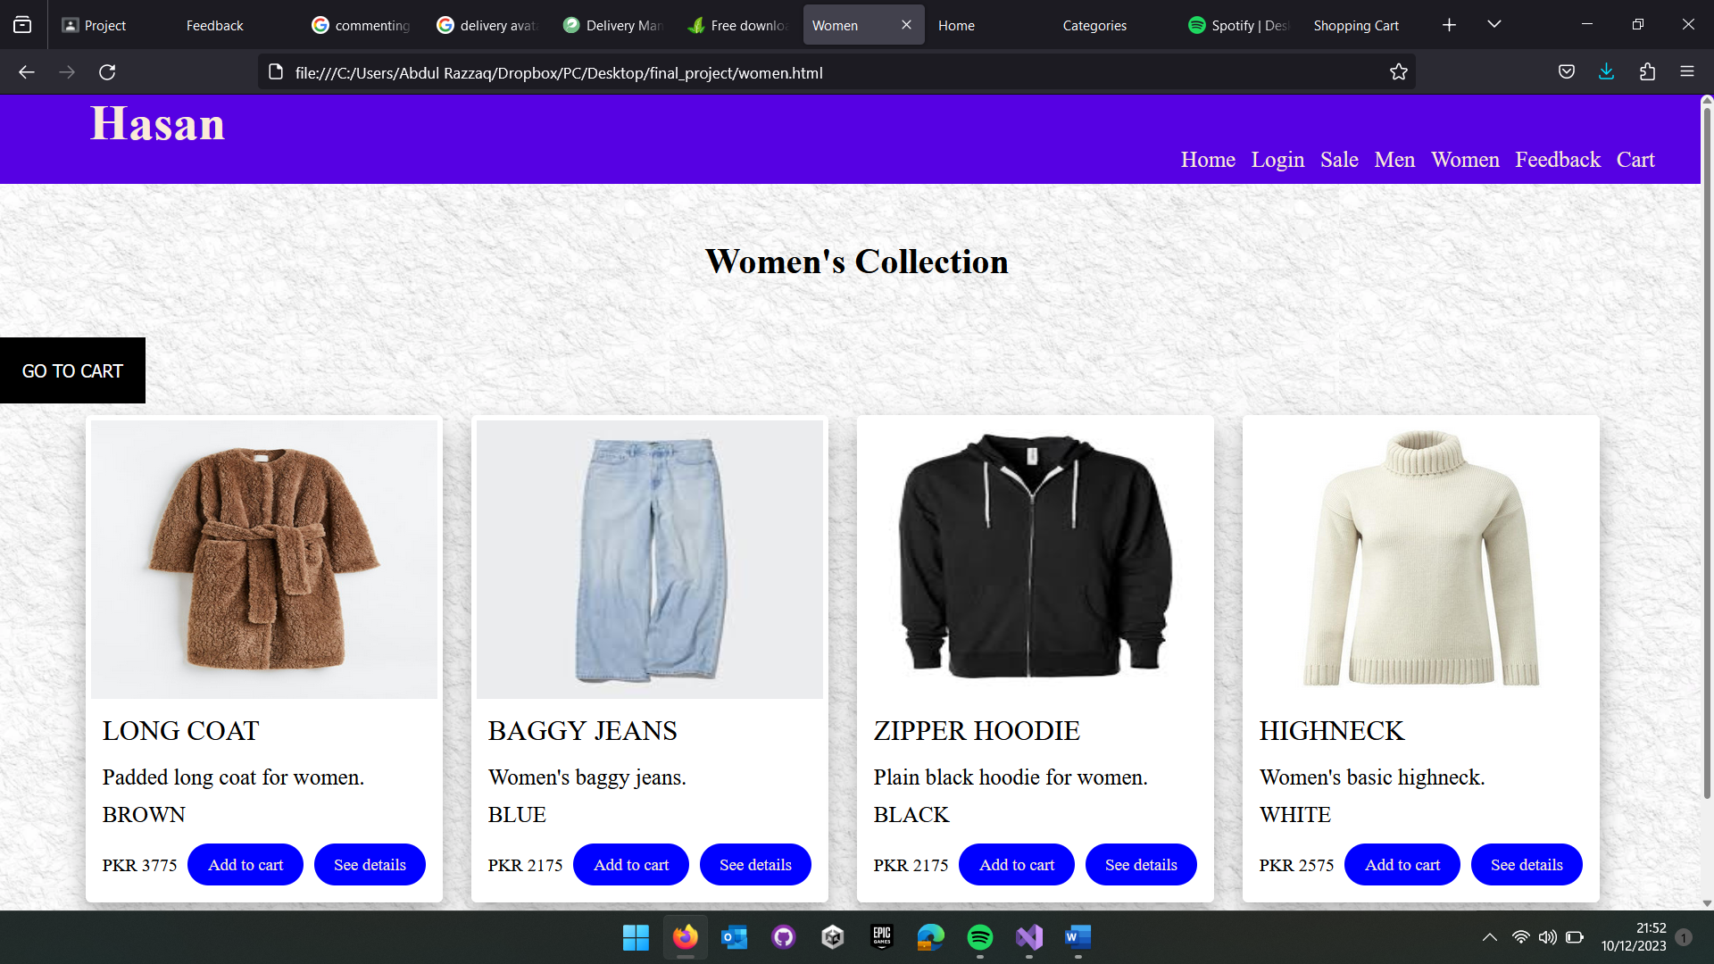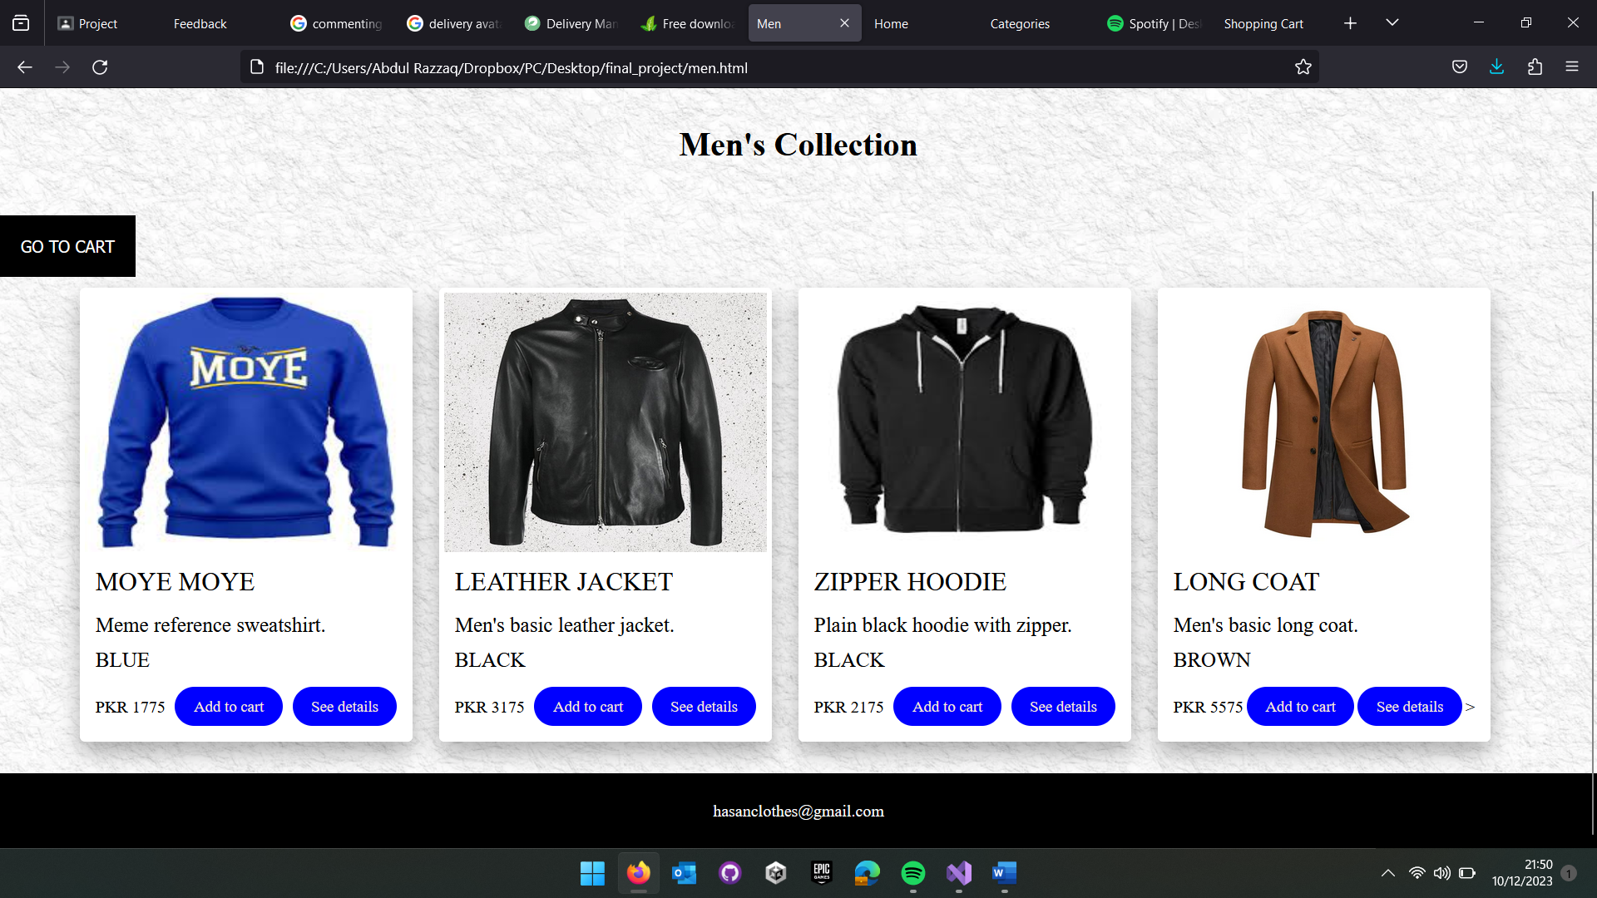

The “Men’s Collection” and “Women’s Collection” page shows a list of available items in the men category, clicking on add to cart adds the item to the cart of the user, clicking on “see details” takes the user to another page where description and other relevant details of the selected item are mentioned. A “go to cart” option is also available on each page which takes the user to cart page.

# PRODUCT DETAILS

# 

The page has details of the product as well as options to add the product to cart and go to the cart. It also has a list of products that are related to the one being viewed.

# CART

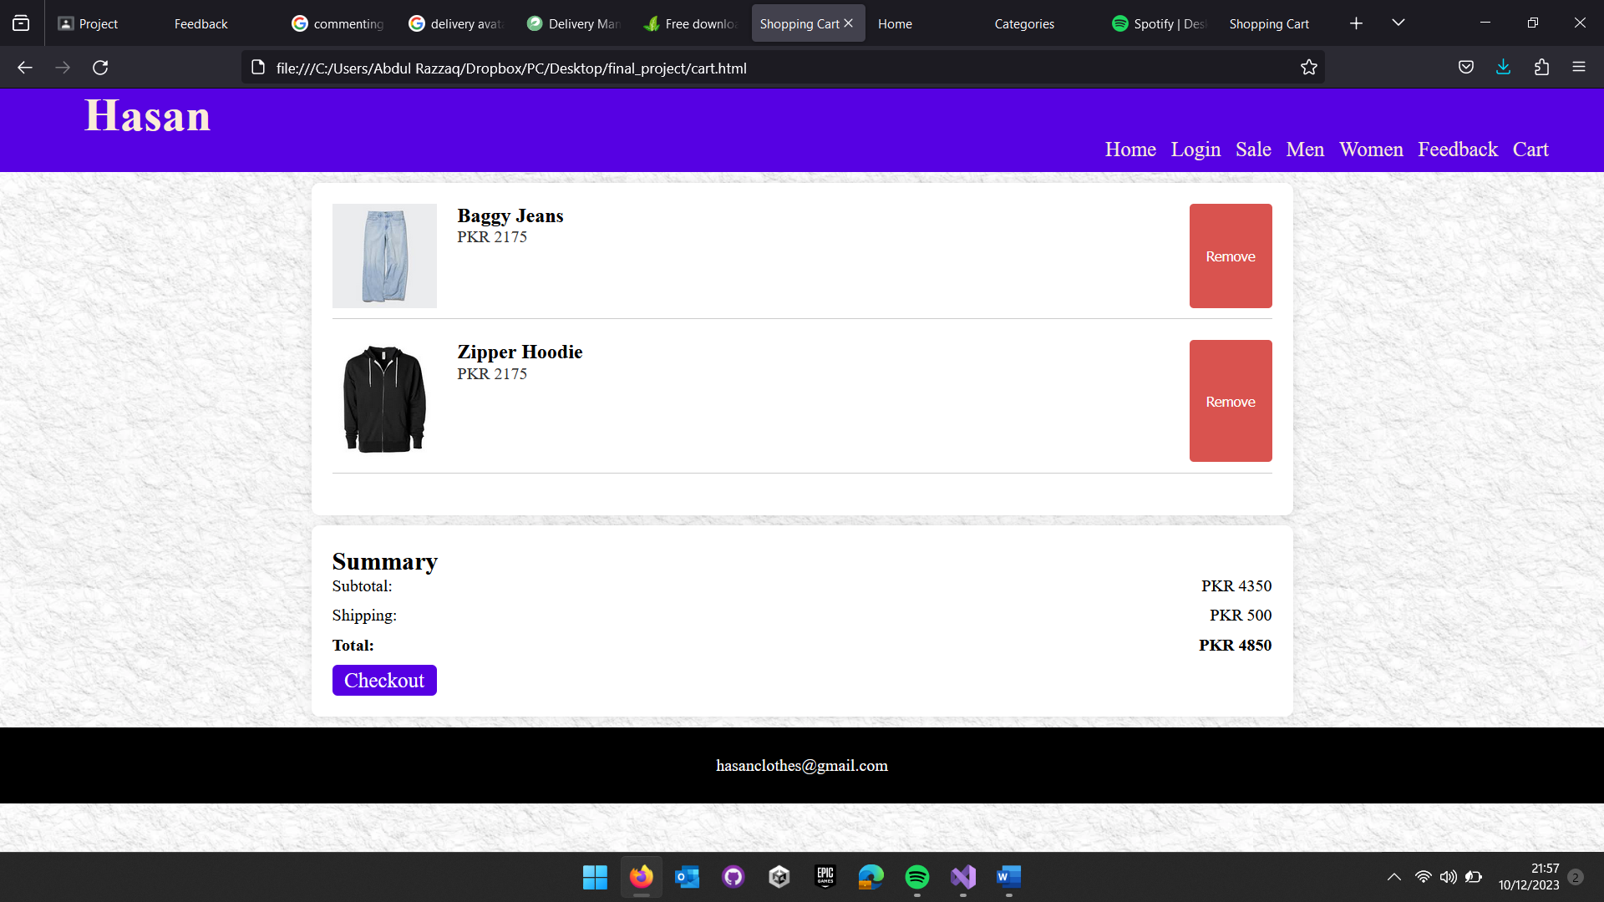

The cart webpage showing a list of items added to the cart, summary of the amount, as well as an option to proceed with the checkout.

# CHECKOUT

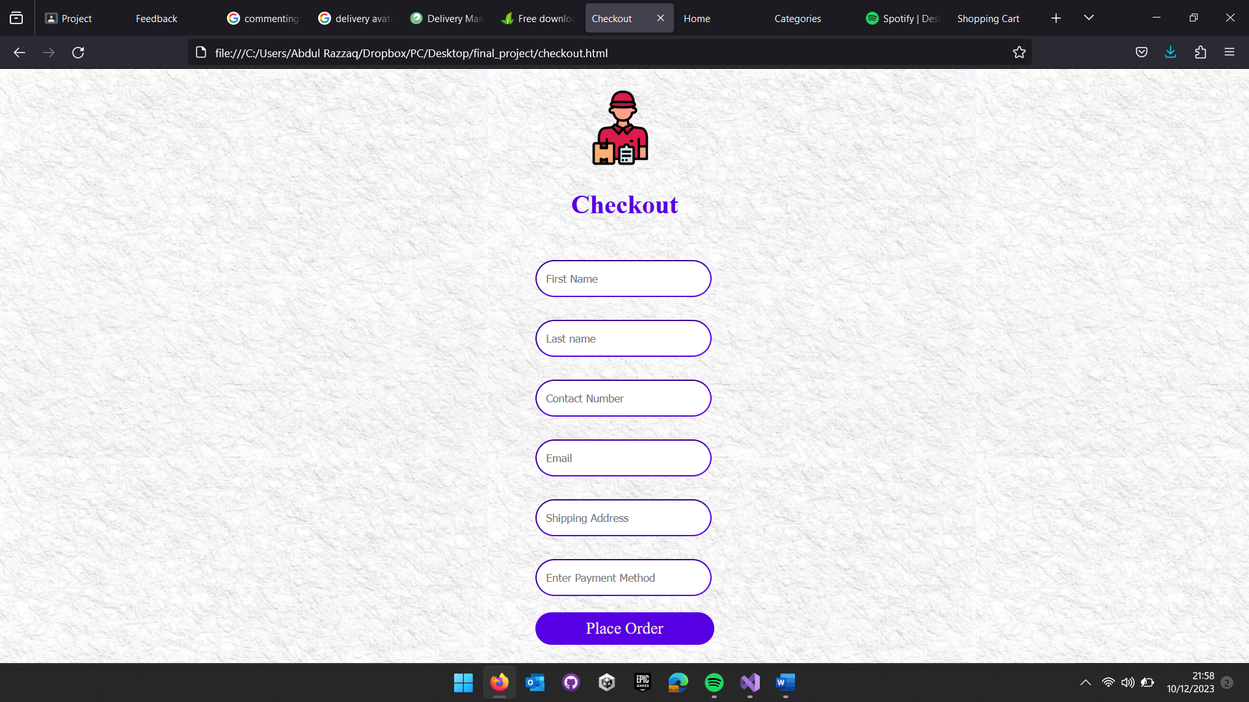

The checkout page asking the user to enter his personal and payment details for confirming the order.